Computer Language, Flat & Structured Interchange

Automatic Containment
The concept of automatic containment is about translating a referential structure to a containment structure.

To be able to work out the idea, some concepts need to be ignored first and reconsidered later (concepts such as globality and physical storage location).

I am working out the idea here as I go along. The explanations may need to be redone in the future.
It must be mentioned, that the method of automatic containment described here, applies to unary references, and not to objects refering to eachother in a dual relation. The notation for dual relations, and the notation of automatic containment described here, just do not match yet, unfortunately. In the future it must be further worked out how to best turn them into a single notation.

A slice of referential structure
One thing that will make it doable, to convert a referential structure to a containment structure, is that you will never display the complete referential structure: you will always display a slice of the referential structure. The contents of one object are shown and it goes but x levels deep. That way you always display a slice of the referential structure: cut off from the top at the parent object and cut off at the bottom x levels deep. The containment structure is worked out only for that slice of referential structure.

The main solution
The main solution to converting a referential structure to a containment structure is demonstrated with the following example. The following reference structure is considered:

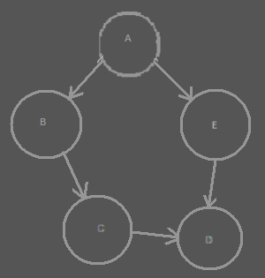

The circles are all objects. Object A for instance has two references: one to object B and one to object E. Two objects refer to object D: both object C and object E refer to object D.

In a Computer Language diagram, the references would look more like this:

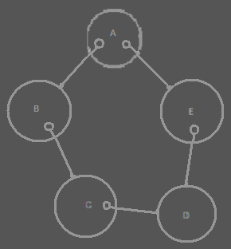

References are considered things that are contained inside an object.

The references are directly converted to a containment structure, by simply displaying one thing inside another thing, instead of one thing referring to another:

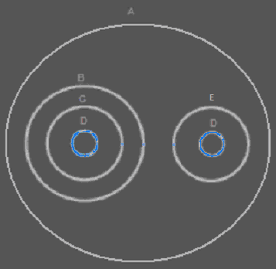

The diagram above actually displays the same structure as the other diagrams: instead of giving object A references to object B and E, object B and E are simply placed directly inside object A. But there is a problem. There are two objects, that have a reference the same object. In the containment structure this means, that two object contain the same object. The same object is displayed twice in the same diagram. In the diagram you can see, that object D is displayed twice: once contained inside object C and once contained inside object E.

The references have a containment position now, but the object didn’t get a fixed position in the containment structure yet.

The main solution to solving the ambiguity of having two symbols represent the same object, is to connect the two symbol that represent the same object with a line:

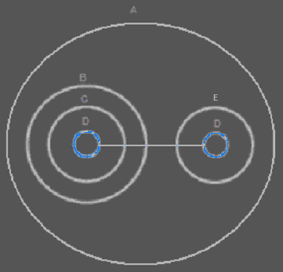

Now both symbols represent the same object.

One symbol is going to be selected to represent the object itself, so that an object gets a fixed containment position, while the other symbols are considered mere references to the object. How a single symbol is selected is explained in the next section.

Regardless of which diagram you find prettier, the containment diagram does display more clearly what is part of what. For instance: you can see that object B indirectly contains object D. That was not that apparent in the referential diagram. But now you have a problem: a single object is not represented by a single symbol anymore.

The closest mutual parent
Multiple symbols in a diagram can represent the same object. In that aspect, a containment diagram does not explicitly express a single place where the object really is. It does not display where the object is, just where the object references are. Only one of the symbols should be considered the object itself, and the other symbols mere references.

To determine the containment position of the actual object, you have to ask yourself: what would the real containment level of the object be? You will have to go upward in the containment hierarchy, until you find the level at which all the references are contained inside a single symbol. That is the actual containment level of the object:

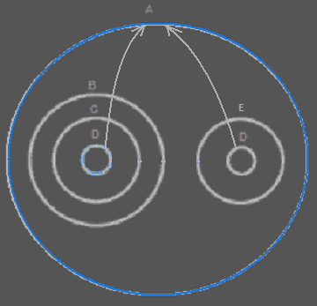

The blue circle is the closest containment level in which both object references are present. It is the larger whole which the object is part of.

The container of the object is also called the closest mutual parent of the object references.

The mutual parent connects all the references together. The mutual parent is the containment position of the object itself.

The diagram above does not even display the symbol, that represents the object itself. We have yet to put a new circle in the diagram directly inside the closest mutual parent of the references:

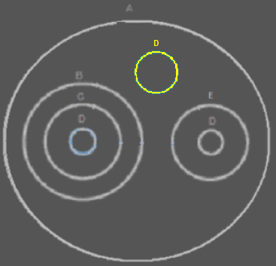

It is an imaginary reference, directly placed inside the closest mutual parent. It is called imaginary, because its container doesn’t really refer to the object directly.

The other references will connect to the symbol that represents the object itself:

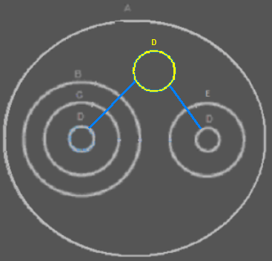

This solves the problem, that multiple things contain the same object. This only happens when the same object is referenced from multiple places.

This is a simple example of expressing the location of an object. The situation can get more complex, though.

Branched out reference lines
Here is a more complex example, in which the reference lines will branch out into a tree structure. This happens when an object is present in several different branches of the containment structure:

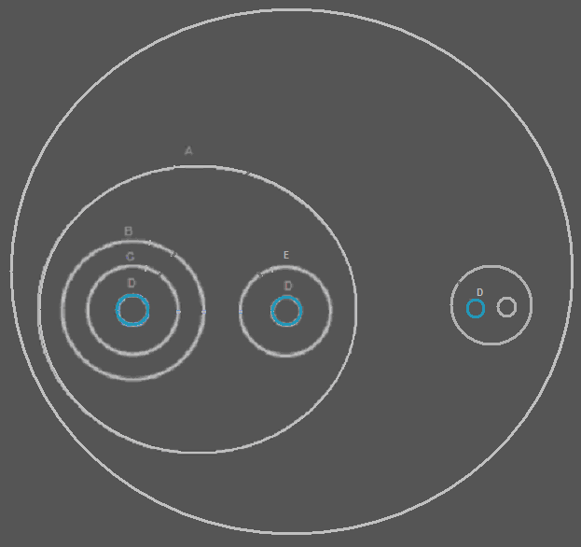

Imaginary references will be created at every mutual parent in the structure, that contains multiple references:

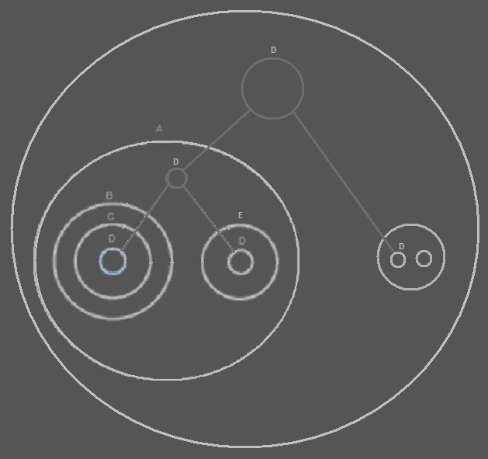

You might say, that all the references to object D could also have been connected to just a single circle on the highest level of containment, instead of creating two circles. But by creating an extra imaginary reference, nodes are displayed at all points at which there is a larger whole, that contains multiple references to the same object.

To find the symbol, that represents the actual object, you have to follow the reference lines upward in the hierarchy. The reference to D on the highest level represents the object itself:

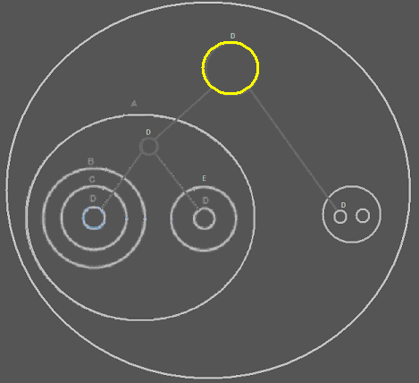

The other symbols of D are mere references to the object.

The containment structure splits up the object structure into branches, and the reference lines branch things back to the same object, and point out the residence of the actual object.

From the target symbol’s point of view, you can easily see in what different places the object is used, because it just directs to them in a tree structure.

Recap
When you display a diagram in a purely referential style, a single symbol represents a single object. There are no multiple symbols, representing the same object.

When you display a reference structure as containment, and there are things, that refer to the same object, then all of a sudden the same object is displayed multiple times and in totally different places.

The diagram does not explicitly display individual objects anymore.

The referential structure is treated directly as a containment structure, but then multiple symbols can represent the same object.

This is solved by connecting the symbols that represent the same object together with lines, to indicate that they are the same object.

But to have a single symbol, that represents the object itself, all symbols of the same object all need to point back to a single symbol. That single symbol represents the object itself. The other symbols are mere references to the object.

But where is this object placed? You’d have to go upward in the containment hierarchy, until you find the level at which all the references are contained inside a single symbol. That is the actual containment level of the object.

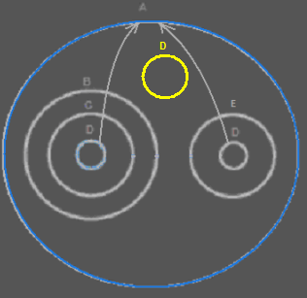

The symbol representing the actual object is placed in the highest mutual parent of all the references.

The references are connected by tying a deeper reference to a higher reference.

The containment structure splits up the object structure into branches, and the reference lines branch things back to the same object.

Inside each symbol, that indirectly contains multiple references to the same object, an new node is created.

That way, a complex referential structure is displayed as a more tangible containment structure, even though it is not pure containment. In that display, multiple symbols represent the same object, but this is elegantly solved, by choosing a clear spot at which to put a single symbol, that represents the object itself, while other symbols are considered mere references to the object. The single symbol is also placed in a spot that is the bigger whole in which multiple object references are contained.

Zooming in, zooming out and making changes
You can move through the diagram by zooming in on a sub object and zooming out to the parent. But a single object can have multiple parents. So the diagram viewer should remember the path you took before you got to the current object, so that it knows what parent to zoom out to again.

Whenever you change something in the object structure, the containment structure of references is easy to draw out, because it is the same as the referential structure. But the reference lines and imaginary references, that make the object references lead back to a single symbol, just need to be wiped out and recalculated. Which of the symbols is a mutual parent can totally change. The reference lines and imaginary references are also recalculated as soon as you move upward in the hierarchy, displaying the contents of the parent of the object you were displaying. The same goes for moving downward in the hierarchy. In all those cases, the reference lines and imaginary references need to be recalculated. Fortunately it is always a limited set of symbols for which you are recalculating this: you are only displaying the contents of a single object, and you display symbols but x levels deep.

<
You can establish a reference to an object, by connecting a reference to an imaginary reference to an object. But in reality the reference shall point to the real location of the object. In the diagram, however, the reference points to an imaginary reference.
>

Analogy to the real world
The way diagrams are displayed, has an analogy to the real world.

Let’s say your TV contains an electronic part. But what if you have a stereo set that also contains this electronic part. When you only focus on the TV, it is the only object that contains this electronic part that you need to be concerned with. When you look at the whole room, you see that this type of electronic part is part of two appliances in the room. Imaginarily, the whole room is the container of this kind of electronic part. The whole room is the indirect mutual parent of both electronic parts of this type, because the room contains two appliances, that directly contain this electronic part. This gives the room an imaginary reference to this type of electronic part. The room doesn’t really contain the electronic part. The appliances could be carried out of the room, and then the room looses its imaginary reference to the electronic part, but the appliances still contain it.

What if you have more appliances in your house, in multiple rooms, that also contain that electronic part. In that case, looking at it from the perspective of your whole house, the whole house has an imaginary reference to the electronic part. This type of electronic part belongs to your whole house in that case. That way you could also look at the whole neighborhood. Perhaps multiple houses contain appliances with the same electronic part in it. In that case this type of electronic part is part of the whole neighborhood. But if you’re just looking at the room you are in, you are not considering the whole neighborhood. You are only bothered with your room. If you focus on just your TV, you just don’t pay attention to the fact that your TV is part of a whole house: the electronic part is just part of your TV.

The containment level of this type of electronic part, just depends on the perspective from which you look at it.

And this is what also happens in the diagrams. That way, something can get a different containment level depending on the perspective from which you look at it. From within that perspective, something does get a unique containment level.

Ignored concepts
To easily understand the idea of automatic containment, a few concepts were ignored. In the sections that follow I will consider the concepts that earlier were ingored.

Here is a sum-up of all the concepts that will be considered here.

- Physical location
- Caching
- Pointers
- Residence on a site
- Central registration lists
- Classes, interfaces and methods
- Fixed logical residence
- Class pointers
- Duality of relations
- Globality

Physical location
The most important concept to explain first, is the physical location of an object.

It turns out I was lying a bit, when I suggested that the target object totally depends on the specific perspective displayed by the diagram. That’s not entirely true. The true target object is stored on a physical storage device.

But if all object references would directly point to the physical storage location of the object, things would turn into an unoverviewable bunch of wiring.

The imaginary references, that were automatically put in between are the answer to making things overviewable when the target object is far away. The imaginary references are intermediate target objects. Those turn reference lines into an overviewable tree structure, the root of which is the target object on physical storage.

Even though on a logical level the same object can be logically resident in different parts of a system, the physical location is fixed.

The logical containment levels are important. They make sure, that you see which objects indirectly contain multiple references to the same object. It also always gives you an intermediate target object to look at, when the real target object is way out of sight: in a diagram, displaying a limited part of the system, there is always one symbol that represents the object itself.

Because the physical location of an object will usually be out of sight, the last intermediate target object, that is in sight, usually points out of the diagram: a reference line, the end of which you don’t see on screen. You could even display the name of the physical location in the reference line going out of the screen. If you go one containment level up, you might find another intermediate reference there.

The storage location gives the object its ID.

Caching
Having a single way to clealy express something’s physical location as well as something’s logical location, makes you able to clearly display multiple cache layers inside a diagram, without obscuring the logical picture. An object is permanently stored on the target storage of a caching scheme. The target object may be on a cached storage, which uses other storages to eventually store things on the target storage. This caching is hidden inside the caching system and is only displayed close to the physical storage (the physical storage is also represented in the diagram). In logical locations of an object stored, you don’t see all this caching and physical storage at all, you just see the logic of the objects, not the storage.

Pointers
The lines connecting to imaginary references are considered imaginary reference lines. In this section I will introduce real reference lines, that are set by a programmer, instead of being automatically set by the system.

In the explanations above the lines simply indicate which symbols represent the same object. Imaginary references in mutual parents are used to indicate which symbols contained by the mutual parent represent the same object. The lines connected to imaginary references are also imaginary: they are not really part of the system. The symbols connected to it, don’t really point to it: in reality they point directly to the target object.

There are also references lines that are real, instead of imaginary. Real reference lines are connected to real object references. These reference lines are not automatically set by the system. They are set by a programmer.

An object reference, that is connected to another object reference with a real reference line is a reference to a reference, a pointer to a pointer, not a pointer to an object. Whenever the target reference starts pointing to another object, a pointers to the reference starts pointing to the other object too.

You can distinguish references to references from imaginary references, because they are displayed differently. Imaginary references look fainter. Real references look bright.

Imaginary reference lines never connect to real references, and real reference lines never connect to imaginary references.

It is important to mention, that when a mutual parent already contains a real reference, this real reference never replaces the imaginary references that are to be put inside mutual parents. Every mutual parent get an imaginary reference to the object it contains, whether there’s a real reference to the object already present there or not.

Also important to stipulate is that lines connected to imaginary references are not real indirections. They are put in between, but everything connected to it, really points directly to the target object.

Imaginary references and imaginary reference lines can change as soon as you change the structure of the program. But real reference lines and real references do not change volatilily, they are actively set by a programmer, and represent pointers to pointers.

Residence on a site
In the first story I gave about automatic containment, I said, that the target object is represented by an imaginary reference put inside the mutual parent of multiple references to the same object.

Later I said that the imaginary reference is really not the target object: the target object is the physical storage of the object.

The fact that an object can have a fixed spot, also makes it possible for an object to reside on a site. When I still suggested that an object didn’t have a fixed location, it was an enigma how I was going to let an object live inside a site, while an object doesn’t have a fixed location at all. Now an object does have a fixed location, it is easy to place it inside a site. A site could host pointers to the physical locations, instead of exposing the target object itself, because you would probably not want other sites to point directly to the place an object is stored or directly see the infrastructrure of the site: what disks and which computers. The infrastructure of the site can be hidden by access controlling it. A site will only be exposing things that others have access to.

If an object is stored on one site, it may logically be resident in multiple locations, but its physical position is still on that site.

Central registration lists
One problem I didn’t want to consider at first, was that a module might contain a registration list of all objects of a certain class. Because that would have given an object an exact location: that would have given an object a fixed place, and all lines would have pointed directly to the central list, which would not make the diagram overviewable.

However, in the method found, I don’t think central registration lists will be a problem anymore. A central registration list does have a place in the diagram, but not all lines are not directly pointing to it, and when it is outside the screen, you only see the closest logical location of the object. The display of the diagram is simply dependant on the level of detail now and lines are usually not pointing directly to a fixed location at all: just to an imaginary logical location. Having central registration lists inside a diagram is really not a problem anymore.

Classes, interfaces and methods
In the stories above only objects were considered. Classes, interfaces and methods were ignored. To cut to the chase: it simply works the same for the display of classes, interfaces and methods.

In Computer Language the class of an object is actually another object. In Computer Language, another object simply serves as the prototype for another object, with default values and everything.

When you first display containment, without lines leading back to a single object and everything, you don’t see mutuality of classes at all. Just like you don’t see mutuality of objects. To express the mutuality of classes, lines and imaginary references are positioned the same way, as they are for lines leading back to the mutual object, but now it is lines leading back to the mutual class. Class lines are dashed instead of solidly drawn.

In Computer Language an interface is also simply an object. An object can serve as the prototype for the interface of another object. When you first display containment, without lines leading back to a single object and everything, you don’t see mutuality of interfaces at all. To express the mutuality of interfaces, lines and imaginary references are positioned the same way, as they are for lines leading back to a mutual object, but now it is lines leading back to the mutual interface (= object serving as a prototype for the interface). Interface lines are dotted, instead of solid.

For methods it works a bit differently. Methods are not objects. Methods are not displayed as circles. Their default display is a square. So they have different symbols compared to objects. But the way lines lead back to a mutual method, simply works the same as for objects. There is more to the display of methods, but that’s not covered here. The main point is: the technique for displaying mutuality of class, interface, and object works for mutuality of methods.

Imaginary object references are always circles, and not triangles or pentagons or anything, because those alternate shapes would give the object a special function, that can only be chosen by a programmer. Imaginary references are created by the system, which does not give the object symbol any other function than to simply be an imaginary reference, so no alternate shapes are required for its notation. For the same reason imaginary method references are always squares and not diamonds or anything else, because this alternate shape would give the method a special function, that can only be chosen by a programmer. Imaginary references are created by the system, which does not give the method symbol any other function than to simply be an imaginary reference to a method.

Fixed logical residence
A target object resides on a storage device. That is the residence of the object. However: classes and methods represent structure of a program. The definition of the structure of a program often not only needs a physical target location. The definition of structure of a program often needs to be part of a module: not just as an intermediate target, that then redirects to the storage device, but as the only target. A single logical location can take the position of the physical target and will become the target. That way you can give something a fixed logical location.

This is important for objects that serve as prototypes for other objects (also known as classes) and it is also important for methods to be able to have a fixed logical location. Normal objects can sort of float around and change residence. They don’t need to be part of one module, they just float around.

Classes and methods however, you might want to make part of a single logical unit. That’s why you need to be able to replace the physical target with a logical one, and let the logical target shadow the physical target, and be the only one referencing the physical target.

Interfaces are also structure definitions that you’d want to give a fixed logical location.

You can also give normal objects a fixed location, so that they become part of a module, and have a fixed logical target location, that shadows the physical storage location.

Class pointers
The pointers concept was igored at first, but now it is clear how to create explicit pointers, instead of just imaginary pointers, you can also imagine how you can keep the class of a sub-object variable, for objects that can manage other object of a variable class. The sub-objects managed all have class pointers to a mutual symbol, symbolically representing the class. That mutual symbol representing the class can be set to point to any arbitrary other class. Whichever class is assigned to the class symbol, becomes the class of the objects managed.

Such genericity of class can be access controlled: you can control whether the class of an object can be changed at all. By default others shouldn’t be changing the class of object references. You made the program and expect the class not to change. Only you can reprogram it. For others the class is fixed. In that sense, using and programming something is only dependent on access control in this Software System. There’s not really a difference between users and programmers in this system. There’s only a difference between what different users can change.

Duality of relations
The concept of duality of relations was ignored at first. Just like the concept of physical location, this concept does change the nature of the diagrams a little bit.

In the diagrams explained before, only mono-directional relations were considered. An object that referred to another object, didn’t refer back to the first object.

In relational programming it is common, that if one thing references another thing, the other thing has a reference back to it. But if you display that in the diagram, then one thing contains another thing, the other thing contains the first thing again, which again contains the other thing; you just see too much recursion, and it is confusing.

Because it is unacceptable not to see this duality in a diagram, the following rules are followed.

Consider first of all, that if something contains another thing, the reference back to the parent is just as apparent as the parent’s reference to a child: just look a container of the child. So the duality of that relation was already displayed in the diagram.

The rule to follow is: if one direction of the relation is already displayed as going downward in the containment structure, don’t display the other direction of the relation as going downward again, because then you will be displaying the same relation twice.

So when something is already displayed as something’s parent, you don’t display the reference back to the parent as a child anymore. The display of a containment is already considered the display of a bi-directional relation.

Just accept the fact, that the display of a parent, is already the display of the reference back.

This may stand a little bit in the way of creating a pointer to a reference: if you create a pointer to a parent, are you creating a pointer to the child's pointer to the parent, or are you creating a pointer to the grandparent pointing to the parent? A good solution for this can be found later.

A funny effect of that is, that when you zoom in on a child, the object formerly displayed as the parent, all of a sudden appears as a child again. Something else funny, is that if you zoom in on that child, the child becomes the parent again and you will be seeing the same thing as when you were two zoom levels up! Now, that’s automatic containment!

When one direction of a relation is displayed, the other direction is not displayed anymore. That is the rule.

One flaw in this is, that you don’t easily see the relation type. An n → n relation is displayed as a 1 → n relation. A n → 1 relation is displayed as a 1 → 1 relation. A solution may need to be found for that. When and how the full relation types between classes can be expressed will be covered in another article, discussing the explicit expression of relations in a diagram.

In this section it is important to understand that a backward relation between objects is always expressed when automatic containment is applied.

Globality
A globality is there to group something into a large whole. Modules and programs are globalities. A site is also a globality. Anything directly inside the globality can be directly referenced from anywhere within the globality. That is the basic principle. However, you don’t have to make everything directly inside the globality accessible globally. If members of a globality are just publically accessible, they are not globally accessible, they are just accessible as members of an object, and not accessible from anywhere within the globality. It’s also not entirely true, that everything inside the globality can access the global members. You can only access global member, from members, whose fixed logical residence is inside the globality. So global things can only be directly accessed from definitions, whose fixed logical residence is inside the globality. Things referenced inside the globality, whose definition is elsewhere, can not access the global members.

A globality is an object. However, it is not represented by a circle, but by a pentagon shape.

You could directly connect lines to the global things, but that will make the diagram unoverviewable. But we already had a solution for that: you make imaginary references.

When the globality itself is not in sight, but you are zoomed in on part of the globality, you are going to see an imaginary reference to the globality. Imaginary references to globality, just like imaginary object references, are positioned in all the mutual parents from which global things are accessed. But unlike imaginary references to objects, nothing has to point to a globality, in order for an imaginary reference to the globality be displayed. An imaginary reference to the globality is always displayed at the highest visible level of containment. You can point to the global things you see inside this imaginary reference. The imaginary references to globality are displayed as pentagons, that’s how you recognize the global things you can access.

You can reference a globality like referencing an object. In that case it behaves like a normal object reference.

You can also reference a globality directly from within another globality. In that case, one globality has a reference to another: one module has a reference to another module. Everything of the referenced module is now globally accessible from anywhere within the other module.

You don’t need to let globalities refer to eachother, to actually let one module use something from another module: one module can always access anything inside another module, whether it has a reference to it or not. A reference however, makes global things from one module, globally accessible inside another module.

The reason why globality was at first ingored when working out automatic containment, is that globality gave things a fixed spot. Everything would have been pointing to a fixed spot, which would make the diagrams unoverviewable. That is the same reason why physical location, residence on a site and central registration lists were ignored.

But this is all solved with imaginary references: the trick to give something referenced multiple times a single logical position inside the containment structure.

Author & Copyright: Jan-Joost van Zon Date: April 12, 2008 – June 26, 2008 Location: Oosterhout, The Netherlands Status: Finished

Ideas
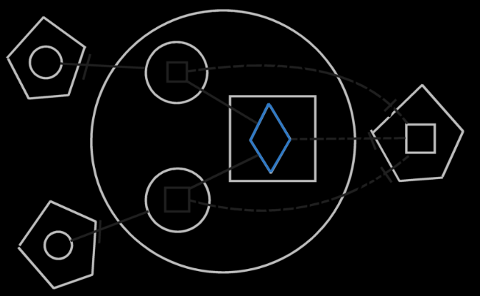

Watch out. The diagrams above suggest that lines don’t always go outwards. But the diagrams are not written well enough. The real imaginary residence of an object or a method defition is not inside the modules where their fixed logical residence is. They are one level higher, because mutual usage extends across the module. If that’s right, then the imaginary target object is different from the real target object … That means that first lines go outward to the imaginary residence, then back inward to the fixed logical residence, and from thereon tot the physical residence. That is weird, however. The lines going inward could from some views be going outward to an imaginary residence. I still need to work this out. Perhaps you just need to see everything as going outward to a certain extent, but the access marks lead to the fixed logical residence.
It’s best not to make a fixed logical residence any more specific than on a site or inside a module. It will get the apprioriate imaginary residences anyway.

< The object symbols and the lines connecting them together together represent the same object. You could draw it out as a solid, making the lines thicker, and you have a single structure that represents the same object. For class lines it’s different: all the symbols in that structure are separate objects, but they are all objects of the same class. The structure represents the same class of object. But one symbol is considered the heart of the structure: the target symbol. >

< I guess you always have a physical target, a logical target and an imaginary target. >

Explicitly connected though parent:

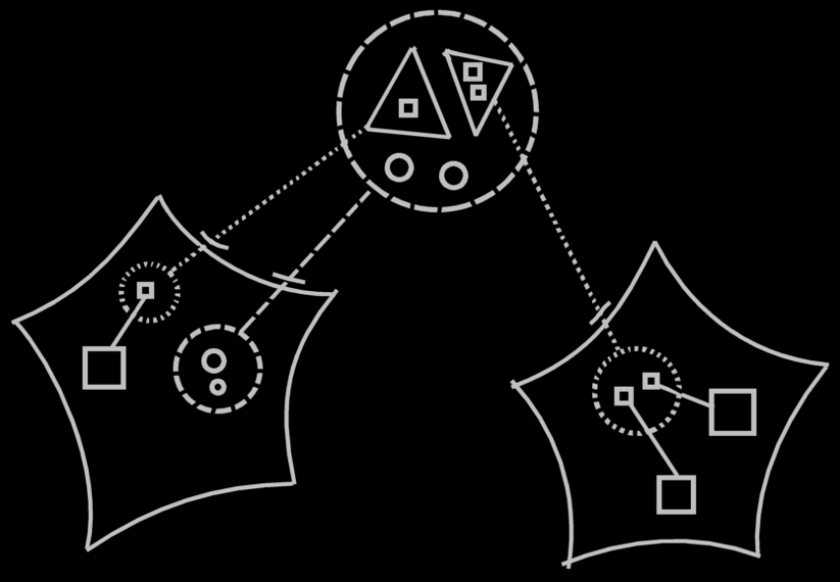

The objects of the class are visible in 2 spots, but not connected though an imaginary references inside the mutual parent, because the connection between the logical class definition and the imaginary class definition already explicitly expressed that it is about the same objects references. However, they aren’t even the same object references, they are just the same object references inside a class.
Formally there are objectg and methods symbols in the diagram that represent the same method, that should be connected through imaginary references to the method or object inside the mutual parent of the references, but this makes the picture less clear.
You can see an implicit connection between the symbols through their parents.
One object may be confused with the other, if implicitly connected like that. You can only recognize them by name, or can possibly by their contents.
But this implicit connection makes the diagram so much clearer. It makes it so much clearer to leave out any connection already implicitly expressed by a connection between their parents.

< I would make implicit connection a part of automatic containment, because automatic containment defines the imaginary references, that we’re going to leave out by implicit connection through connection between parents. >

